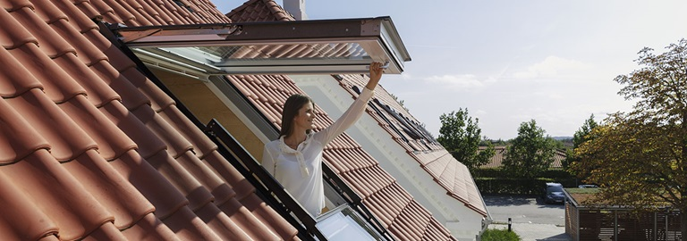

WINDOW BLINDS FOR THE FUTURE

Handout 2 – Case 29

Group Members

Tristan Rottevig Møller, 201706862  
Mads Vikær Lund, 201504445  
Hillal Hamdan, 202010801  
Anisa Mohamed Hassan, 201709369

**Group 21**

Contents

1 The final innovation task: 2

1.1 Sub questions: 2

2 Generating Ideas 2

2.1 Involvement 2

2.2 Leading Style 3

2.3 Brainstorming 3

2.4 Random 3

2.5 Operations 4

2.5.1 SCAMPER 4

2.5.2 Morphological Forced Connections (MFC) 4

2.6 Structuring 7

2.6.1 Edward de Bono – Six Thinking Hats: 7

2.7 Assumption 8

2.7.1 Assumption reverse: 8

2.8 Analogy 9

3 Bibliography 11

4 Appendix A1 12

5 Appendix A2 13

# The final innovation task:

There are three major aspects that should be challenged: sustainability, Smart Home integration and livability. The future model should address them as a holistic solution. The ultimate objective of future construction is three-fold. It should ensure that the energy consumed in the construction and subsequent use of a building is considered in the design phase; it should employ modern technology and visionary design to create an efficient building envelope without compromising the highest standards of comfort and health; and it should have the lowest possible impact on the climate by using renewable energy sources and adopting the concept of climate payback.

It would perhaps be naive to assume that it would be possible to fulfill all these requirements without extensive domain knowledge, so the innovation task is boiled down to sub questions to enable the creation of ideas that solve one or several of the requirements/aspects.

## Sub questions:

All innovation ideas should consider sustainability and environmentally friendly.

1. A fully autonomous and automated window (blind) that can integrate with 3rd party SMART HOME vendors/applications. (e.g. Apple Home)
2. A solution that solves the block/ventilation dilemma. It would be ideal to be able to ventilate and be able to block out the heat/light.
3. How to integrate (more) sustainability in window blinds
4. How can we minimize heat loss in roof windows?
5. How can reduce the energy emission efficiency?
6. How can we control the outdoor climate thru our windows?
7. Is the installation of Velux windows will set up my future home design?

**PLEASE ADD MORE QUESTIONS IF YOUR IDEA DOES NOT FIT UNDER THE SUBQUESTIONS! :D**

# Generating Ideas

… Introduction …

… How did we decide on how to make ideas …

… What areas / methods did we use ….

… Something about playstorming? …

## Involvement

* Who was involved in the

## Leading Style

* Something about corona not letting us meet physical… perhaps reference trello board and task delegation?

## Brainstorming

Brainstorming is an informal approach to problem solving with lateral thinking. While some of these ideas can become solutions to a problem, others can spark more ideas. First, we tried to brainstorm ideas for the problem, but found out later that it was rather difficult. Instead we brainstorm to different areas to the problem, like material used, ways to operate the system and extra features that could be interesting to add. To all the different material input is an operating system.

Here is a list of the different ideas that were created:

1. Tinted window glass instead of blinds.
2. Anti-UV fabric blinds
3. Recycled plastic blinds
4. Recyclable plastic glass
5. Acrylic Windows
6. Plexiglass windows
7. Polycarbonate Windows
8. Metal plates, instead of glass. And when they separate, they let air and light in.
9. Wood blinds or Thermal fabric + automated and remote
10. Digital shades, where the color and transparency can be controls
11. Two-way mirror with metal coating, where x% light can pass
12. Skylight shades + automated and remote control
13. Window blinds system with rechargeable battery
14. Window blinds system that use solar power to recharge battery
15. Window blinds system that can be Bluetooth operated
16. Window blinds system that can connect to other Smart home devices
17. Voice command-controlled window blinds system
18. Add sensors, like temperature or humility

## Random

1. Outdoor shades, that are places outside the window
   * Could be made from plastic or metal
2. Window glass with blinds in between two pieces glass
3. **Technology that can be added to existing blinds?**

## Operations

Operation is to place a well-defined problem, a situation or even a challenge into a method where defined operation have to be done in the process of obtaining ideas (Sejer, 2021). The method challenges the problem definition often in relation to existing products and technologies. In this section two different tools with be used SCAMPER (MindTools, 2021) & Morphological Forced Connections (Mycoted, 2021).

### SCAMPER

The SCAMPER mnemonic stands for *Substitute, Combine, Adapt, Modify, Put to another use, Eliminate and Reverse*. The focus lies in asking questions about existing products in regards with the problem definition. In Handout 1, section 1.3 (Appendix A2) several technologies and products were analyzed in relation to the task given by VELUX. Most of the elements were ‘high-end’ and the final comparison matrix was highly biased because of this. The SCAMPER tools forces one to ‘challenge’ all aspects of the product/problem domain.

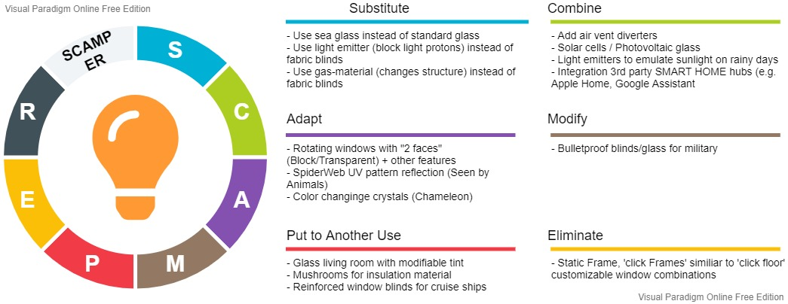

Figure 1 - Ideas using the SCAMPER mnemonic. The diagram includes links to different idea sources, please refer to Appendix A1.

### Morphological Forced Connections (MFC)

MFC is heavily reliant on product analysis, since to utilize it the user must create attribute columns relevant for the potential invention. This can seem somewhat restricting, but it is an efficient tool to generate ‘invention’ from random combinations of column attributes (e.g. material, shape, color and other aspects).

The chosen column attributes are *shape*, *placement*, *blind & window material, handling/movement*, *technique (heat/insulation).* Values placed within an attribute column are called variables. Variables can be changed into codes to facilitate the process of combining morphology. Combinations are made by taking one variable from each column to be combined with one other variable from each column (Sheila Andita Putri, 2019).

Table 1 - Morphological Forced Connection Matrix. Some of the variables used in the matrix are inspired by previous idea generation. Placement column references the placement of the blind and not the actual window frame. If the placement Is ‘away’ from the window the blind might need to another form, but that is not part of the exercise.

|  |  |  |  |  |  |
| --- | --- | --- | --- | --- | --- |
| Shape (S) | Placement (P) | Blind Material (B) | Window Material (W) | Handling/Move (H) | Technique (T) |
| Square | Outside away from window | Anti-Heat  (VELUX , 2021) | Plastic | Manual | Polystyrene foam |
| Round | Outside close to window | Blackout energy pleated  (VELUX, 2021) | ‘Regular’ Glass | Autonomous | Fiberglass |
| Triangle | Inside close to window | Translucent pleated blinds  (VELUX , 2021) | Photovoltaic  Glass | Automated | Batt insulation |
| Rectangle | Inside away from the window | Cellular Shades  (Stoneside, 2021) | Electrochromic  Glass | Touch | Mushrooms |
|  | Inside the pane or on the pane | A lot of other types, see (Yorkshire Fabric Shop, 2021) | Sea Glass | 3rd Party Application | Window film |

Table 2 - Morphological Matrix. Take random ‘paths’ through the matrix to create an alternative invention using known product capabilities.

|  |  |  |  |  |
| --- | --- | --- | --- | --- |
| Variable 1 | Variable 2 | Variable 3 | Variable 4 | Variable 5 |
| S1 | P1 | B1 | W1 | T1 |
| S2 | P2 | B2 | W2 | T2 |
| S3 | P3 | B3 | W3 | T3 |
| S4 | P4 | B4 | W4 | T4 |
|  | P5 | B5 … BN | W5 | T5 |

The variables are combined based on values in Table 2. Below are a few examples of combination, where some contains the idea description – for others please refer to the table.

Table 3 - Realistic combinations and idea description

|  |  |
| --- | --- |
| Combination | Idea |
| [S4, P1, B1, W3, H5, T1] | A rectangle window with the blind placed away from the window using anti-heat blind material, photovoltaic glass, manipulated via 3rd party application and standard polystyrene foam. |
| [S1, P5, B3, W4, H4, T1] | A square window with blind placed inside the pane using translucent pleated blind material, electrochromic tinted glass, manipulated via integrated touch mechanism and window film insulation. |
| [S3, P2, B2, W1, H1, T2] | See Table 2 – An interesting feature of triangular shape (S3) is combining several of them to form pattern |
| [S4, P4, B5, W4, H2, T5] | See Table 2 |
| [S1, P2, B2, W5, H1, T1] | See Table 2 |

None of these ideas (presented in this section) as themselves fulfill all the requirements stated in the innovation task. However, some of them might be a means to an end concerning the sub-questions and by combining several ideas it might come close to fulfilling all requirements.

## Structuring

### Edward de Bono – Six Thinking Hats:

With this technique the ideas created comes from dividing the though process into 6 different areas symbolized as hats. This makes it easier for the person/group to focus on creating ideas with one subject in mind.

The different hats are as follow:

1. 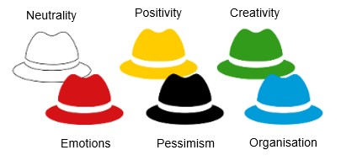The white hat – Facts
2. Yellow hat – Brightness and optimism
3. Black hat – Risk management
4. Red Hat – Feelings
5. Green – creativity, alternatives, and new ideas
6. Blue hat – management hat

*Ideas:*

1. Use only sustainable materials
2. Reduce heat loss by removing windows and create artificial light which is seen as natural light
3. Optimize air flow between glass to remove air
4. Create a film which can change from letting heat in to letting heat out when adding electricity
5. Since glass is reusable then make houses out of glass
6. Implement a liquid between the glasses to remove heat/reject it
7. Integrate how much light a glass lets in into a smart technology
8. Use fase change of a liquid between two glass windows to stop/let light
9. Makes holes in the window frame to let heat out air in
   1. Sell added fan which fit these holes
10. Create windows where the glass can easily be switch out from a “winter” glass to a “sommer” glass
11. Integrate solar panels into window blinds

## Assumption

### Assumption reverse:

Assumption reverse is a technique which challenge the ideas which the person currently has. By forcing him/her to create assumption which are present and reverse them it creates a different image on the case.

*The method works as the follow:*

Create assumptions about the customer – for example who they are, what they do for a living or why they buy a window

Reverse the statement to the opposite and use his statement to suggest ideas

Assumptions:

* People who buy windows from Velux have the money to environmentally friendly window blinds
* Window blinds protect against heat/light getting in
* Windows are transparent so that people can look outside
* Windows are usually open in the summer and closed in the winter

Reversal:

* People who buy windows from Velux do NOT have the money to environmentally friendly window blinds
* Window blinds let heat and light in
* Windows are not transparent, and people can’t see through it
* Windows are closed in the summer and open in the winter

Suggest ideas:

* Make it easier to be environmentally friendly
* Make windows that only let heat in and combine with removal of heat/cooling from other sources
* Make the heat go out in the out and stop the cold to come in in the winter

1. Cut the cost of window blinds by using cheap recycled window blinds
2. Remove windows and make transparent walls
3. Integrate several window blinds which are great for different situations
4. Combine change in window blinds with tracking of heating, light, humidity
5. Add air filters to the air intake in the window frame
6. Make windows upgradable and remove the need of “new” windows each time
7. Prolong the lifespan of window blinds by increasing material thickness
8. Prolong the lifespan of window blinds by using more expensive materials
9. Use the same technology in screen for anti-glare in windows
10. Double layer window blinds which let air in but not light
11. Filters on the windows which becomes dark when light hit it
12. Make window ultra-reflective so the light reflects and do not let heat it
13. Integrate temperature measurement of the house to choose whether or not to let light in
14. Insert rotatable mirrors in the window which reflects the light away from the customer
15. Make soundproof windows

## Analogy

Natural process is used them as inspiration to find analogous input that target our problem statement. Example of analogy used in this stage is biomimicry of some organisms to blend in the surrounding.

In other words, biomimicry makes us think about the forest as well as the trees.

|  |  |  |
| --- | --- | --- |
|  | **Analogy Solutions** | **Real solutions (Velux window)** |
| What’s it like?    It’s like to have a spider web, an eco-system that grows.. | * Evolve to survive * Adapt to changing conditions * Be locally attuned and responsive * Integrate development with growth * Be resource efficient   (material and energy)   * Use life-friendly chemistry | • Roof windows – a wide range of various  roof windows to match any need  • Blinds and shutters – that control daylight and heat with functional, decorative and easy-to-install window accessories that allow for individual needs and preferences.  • Solar energy systems – that supply  hot water and room heating and have  been designed to optimize effective-  ness, aesthetics and convenience  • Installation products – that ensure  a tight seal between window and roof  construction  • Home automation – electrically operated  windows, blinds and shutters bring intelligent technology that optimize comfort.  On winter nights  the insulating effect  heat loss. |

# Bibliography

MindTools. (2021, 03 27). *SCAMPER*. Retrieved from MindTools: https://www.mindtools.com/pages/article/newCT_02.htm

Mycoted. (2021, 03 28). *Morphological Forced Connections*. Retrieved from mycoted: https://www.mycoted.com/Morphological_Forced_Connections

Sejer, H. (2021). *Ideation Slides .* Aarhus : Aarhus University.

Sheila Andita Putri, Y. P. (2019, 01 01). *Morphological Forced Connection Method Application in the*. Retrieved from Media: https://media.neliti.com/media/publications/293284-morphological-forced-connection-method-a-e18c4f34.pdf

Stoneside. (2021, 03 28). *4 Modern Window Treatments to Use as an Alternative to Blinds*. Retrieved from Stoneside: https://www.stoneside.com/resources/articles/4-modern-window-treatments-to-use-as-an-alternative-to-blinds

VELUX . (2021, 03 28). *SWATCH SAMPLES*. Retrieved from VELUX: https://www.veluxblindsdirect.co.uk/product/colour-samples?consent=preferences,statistics,marketing&ref-original=https%3A%2F%2Fwww.google.com%2F

VELUX. (2021, 03 28). *Blackout Energy Plated Blind*. Retrieved from VELUX: https://www.velux.co.uk/products/blinds-and-shutters/blackout-energy-blinds?consent=preferences,statistics,marketing&ref-original=https%3A%2F%2Fwww.google.com%2F

VELUX Group. (2021, 03 17). *Sustainability is the way we do business*. Retrieved from VELUX.

Yorkshire Fabric Shop. (2021, 03 28). *Made to Measure Curtains*. Retrieved from yorkshirefabricshop: https://www.yorkshirefabricshop.com/made-to-measure-curtains

# Appendix A1



# Appendix A2

